THE BOURBONS IN SPAIN

The War of the Spanish Succession

In 1700, Carlos II died with no heirs. This caused a conflict regarding his succession between the French candidate, Felipe of Bourbon (grandson of Louis XIV), and the Austrian candidate, Carlos of Habsburg.

Carlos II had appointed Felipe as his successor, so he was proclaimed king (Felipe V).
However, Carlos of Habsburg did not accept this and the War of the Spanish Succession (1701-1713) began.
This had two components:

- A civil war: most territories of the Crown of Aragón were worried about losing their rights and institutions, so they supported Carlos of Habsburg, while Castile supported Felipe V. After the Battle of Almansa in 1707, the troops loyal to Felipe V occupied Valencia and Aragón. The war ended in Catalonia in 1714 when Barcelona was conquered, and in Mallorca a year later.

- An international conflict: Britain, the Netherlands, Portugal and the Austrian Empire were concerned about the Bourbons’ growing strength in Europe, so they supported Archduke Carlos and declared war on Spain and France. The appointment of Carlos of Habsburg as Holy Roman Emperor led to the end of the conflict, as his international supporters rejected a revival of Austrian power and wanted a balance of power in Europe.

The international powers signed the Treaty of Utrecht (1713), which established Britain as the main power and recognised Felipe V as king of Spain in exchange for major concessions.

THE CONSEQUENCES OF THE TREATY OF UTRECHT

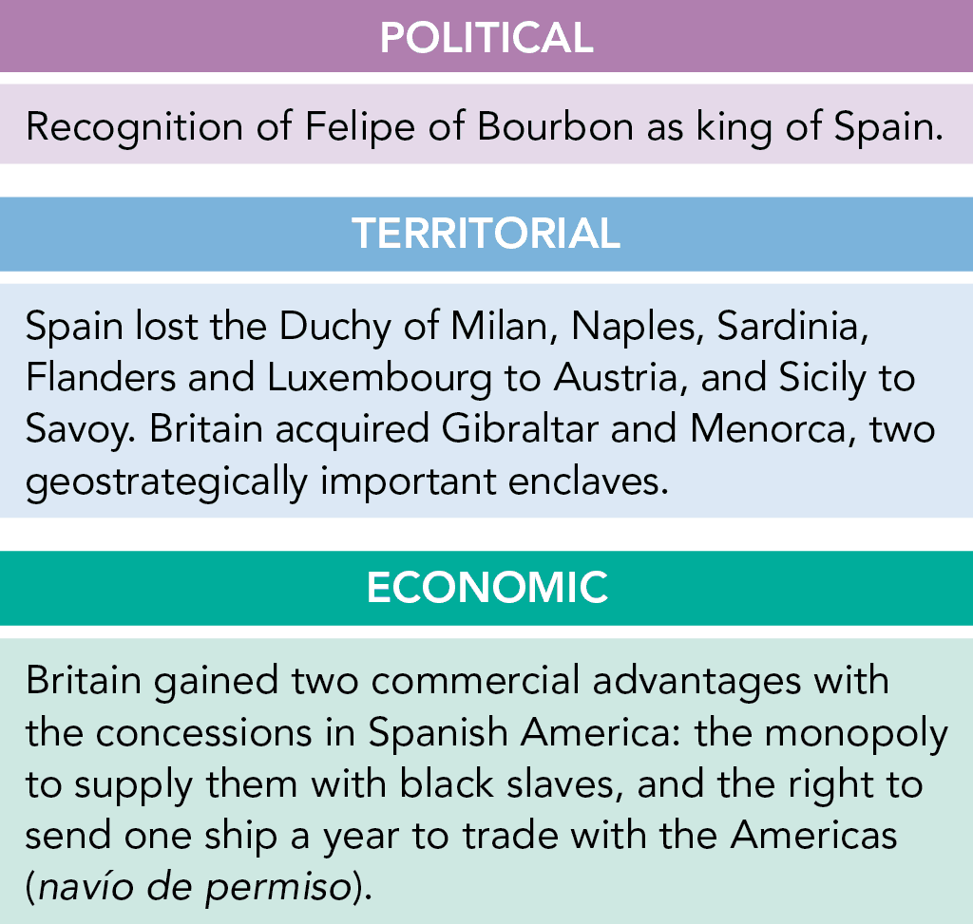

The reign of Felipe V

During the reign of Felipe V (1700-1746), measures were taken to implement the French absolutist model and revise the Treaty of Utrecht:
- Between 1701 and 1716, the Nueva Planta decrees were adopted. These abolished the laws and institutions of the territories of the Crown of Aragón (Aragón, Valencia, Catalonia and Mallorca) and put an end to the composite monarchy.
- Administrative reorganization: the Cortes were abolished, except in Castile, and the councils lost power .
- Revision of the Treaty of Utrecht: foreign policy aimed to recover some of the territories lost in Utrecht. To achieve this, Spain signed two pacts with France. After several conflicts, the kingdom of Naples, Sicily and the Duchy of Parma were restored.

The reign of Fernando VII

Fernando VI (1746-1759) appointed reformist politicians, including the Marquess of Ensenada as Secretarios de Estado. During his reign, a policy of neutrality and peace and a series of reforms were promoted:
- A single tax was proposed to unify the tax system in Castile, but this was never introduced. However, the Catastro of Ensenada, a register of properties, was created.
- To defend the colonies, the navy was reformed and ships were constructed in Ferrol, Cartagena and Cádiz.
- To help transport wheat from Castile to the northern ports, construction work on the Canal of Castile began.
- To control the appointment of high church officials, a Concordat was signed with the Pope.

The enlightened despotism of Carlos III

Carlos III (1759-1788) was the greatest exponent of enlightened despotism in Spain. He promoted reforms but did not renounce his power or change the country's social structures.
He used his experience as king of Naples and Sicily and took advice from Italian ministers, such as Esquilache and Grimaldi, to introduce economic reforms.
These measures were opposed by the working and privileged classes.

In 1766, this opposition led to the Esquilache Riots, a popular rebellion against the high wheat prices and taxes. It was probably instigated by the nobility and clergy, whose power had decreased.

After the rebellion, politicians such as the Count of Floridablanca, the Count of Aranda and the Count of Campomanes gained significant power and promoted measures:

- The Jesuits were expelled (1767). This increased the monarchy's control over the Church.
- New primary schools were created, and university education was reformed.
- The privileges of the Mesta were reduced to boost agriculture.
- All Spanish ports were allowed to trade with America (1778) and the National Bank of San Carlos was created.

